Ahmad Karkouti

21269015



Functional programming

Element 2

Table of Contents

INTRODUCTION 2

RACKET 3

MULTIREMBER 4

Rember 4

Testing Rember 4

Multirember 5

Conclusion 5

# INTRODUCTION

# RACKET

Racket is a programming language in the Lisp-Scheme family. Part of its goal is to operate as a platform for language creation, design, and implementation

# MULTIREMBER

## Rember

In order to explain “Multirember”, I first have to explain “Rember”.

Rember is a function that removes the first argument from the first atom in the second argument. We first start by defining the function “rember”../Desktop/Screen%20Shot%202018-02-26%20at%207.25.34%20AM.png

Then we call “lambda” which is an anonymous function and we allocate it with 2 arguments.

../Desktop/Screen%20Shot%202018-02-26%20at%207.27.52%20AM.png

within that function we start a condition

../Desktop/Screen%20Shot%202018-02-26%20at%207.29.00%20AM.png

if “lat” is null which means if lat does not contain any atom, it will check if the first atom in lat = to the rest of lat and output the empty list.



Or else, if “lat” is not null which means the list contains at least 1 atom. Construct a new list excluding the first atom from the list “lat” that is equals to the first argument a



## Testing Rember

In order to test “Rember” we have to first call the function and provide it with 2 arguments just like we defined 2 arguments for it in the above code at “lambda (a lat)”.

So, we started by calling the function “rember”, set the first argument “blue” and we set the second argument as an empty list

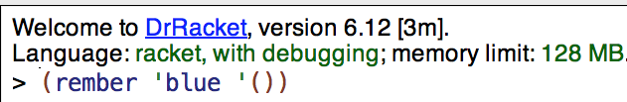

What that is expected to do is return the empty list since “lat” is null as explained in the above code, when “lat” is null, and the first atom of lat is equal to the rest of lat, the empty list will be returned. ../Desktop/Screen%20Shot%202018-02-26%20at%207.49.31%20AM.png

## Multirember

# Conclusion